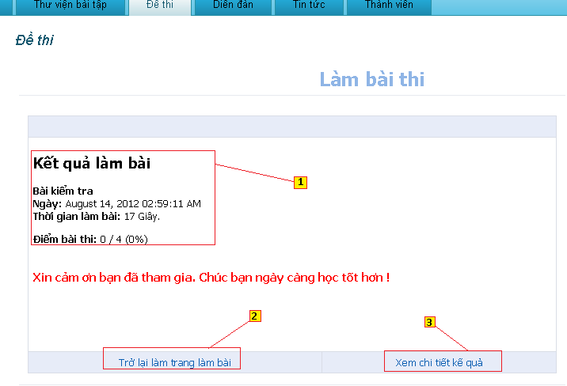

**Figure 6.36:** Result exam page

**Functions of exam after finish test include the following:**

* + **[1] Content panel:** Show result of exam.
  + **[2] Link “Trở lại trang làm bài”:** Go to page select exam.
  + **[3] Link “Xem chi tiết kết qủa”:** Go to page show result each of question.

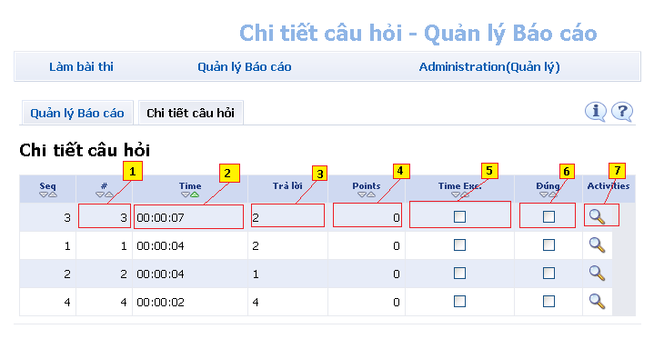

**Figure 6.36:** Specific question

**Functions of exam after finish test show specific question include the following:**

* + **[1] Cell ID of table:** show ID of question.
  + **[2] Cell time of table:** show time finish question.
  + **[3] Cell show number of answer:** show number of right answer.
  + **[4] Cell point:** Show point of questions.
  + **[5] Cell time Exceeded:** show time exceeded.
  + **[6] Cell show good answer:** show questions are selected right answer.
  + **[7] Link button:** View specification of question.

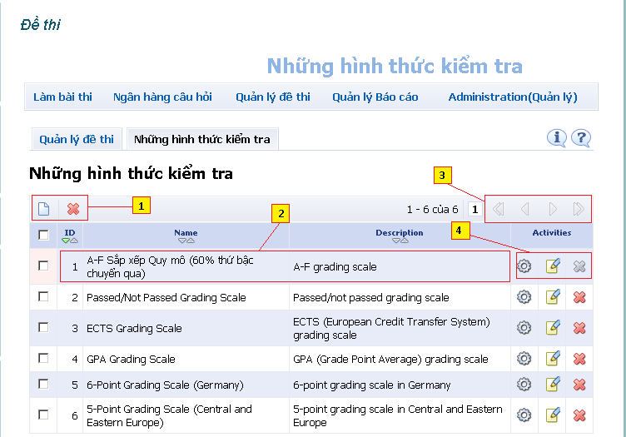

**Figure 6.37:** Select type of exam

**Functions show, add, delete type of exam include the following:**

* + **[1] Button add and delete:** Add or delete types of exam are selected.
  + **[2] Cell in table:** ID, Name and Description of types of exam.
  + **[3] Button next and back:** next and back page of table.
  + **[4] Button setting and change content:** change setting of types exam.

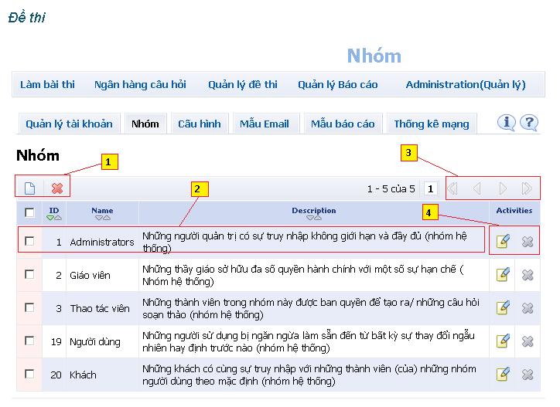

**Figure 6.38:** Page manage group.

**Functions show, add, delete groups in exam include the following:**

* + **[1] Button add and delete:** Add and delete groups are selected.
  + **[2] Cell of table:** show ID, Name and Description of groups.
  + **[3] Button next and back:** button next, back, go to last page, first page of table.
  + **[4] button change or delete:** change and delete activities of groups.

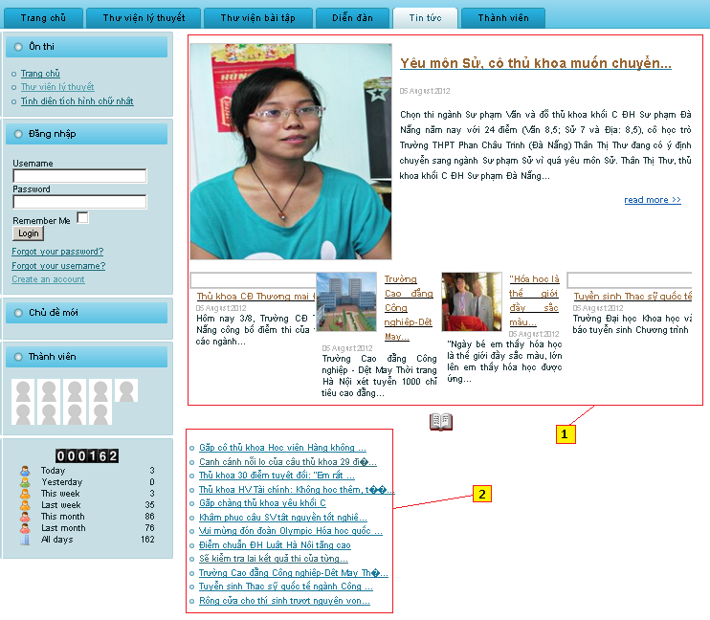

**Figure 6.39:** Page News of home site

**Functions show news in home site in tab “Tin tức” includes the following:**

* + **[1] Content panel:** show hot news.
  + **[2] Link of news:** Link to show relate news.